Warmflow High Efficiency Ground Source Heat Pump Ecodesign End-of-Life Information
Commission Regulation (EU) No 813/2013
End-of-Life Information
Warmflow High Efficiency Ground Source Heat Pumps must be disposed of according to local regulations by using a public or private waste collection service.
Safety Risks
Prior to disassembly, the appliance should be electrically isolated and disconnected.
Refrigeration gas (R410A) should be recovered and disposed of by an F-Gas registered engineer.
Any fluids within the appliance must be drained, and disposed of in-line with local regulations.
Care should be taken when handling the appliance due to weight, use appropriate PPE and lifting aids.
Polyisocyanurate foam insulation – suitable PPE should be used for respiration protection, and to avoid skin or eye contact.
Disassembly of the Product
The main materials of the components are:
- Mild Steel
- Stainless Steel
- Copper
- Brass
- Polyisocyanurate Foam
- Neoprene Foam
- Polyurethane Foam
- Plastic Components
- Electronic Components
These may be recycled – depending on the local recycling facilities available.
The appliance is assembled by using mechanical fasteners and can be disassembled with standard tools.

The components of a typical appliance are shown below (not all components may be fitted, depending on appliance specification)
Casing and key components
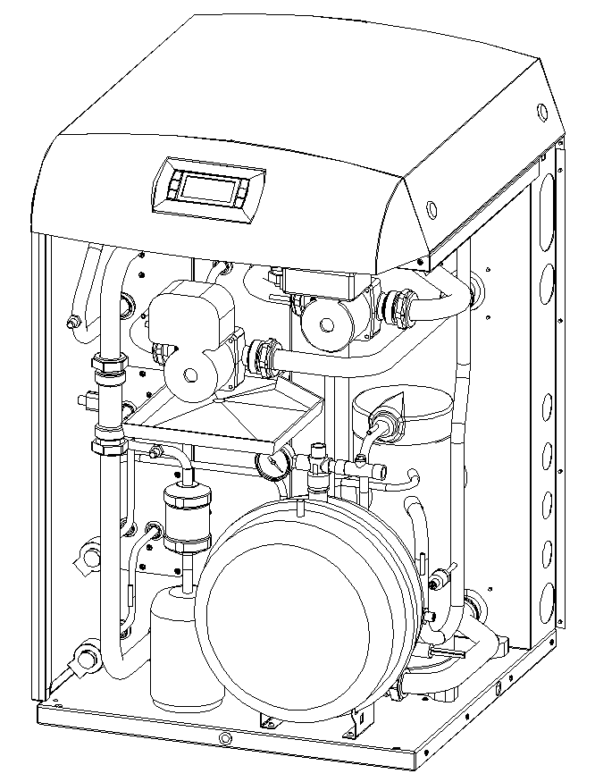
12
111
10
9
8
7
6
5
4
3
2
1
Item | Description | Main Materials | Special Notes
1 | Casing | Coated Galvanised Steel
2 | User Interface | Plastic, Electronic Components
3 | Circulating Pumps | Steel, Stainless Steel, Plastic | Consult Component Manufacturer
4 | Drip Tray | Plastic
5 | Flow Sensors | Plastic
6 | Filter | Steel, Ceramic
7 | Pipework Assembly | Copper, Brass, Neoprene Foam
8 | Receiver | Steel, Copper
9 | Compressor | Steel, Copper, Rubber | Consult Component Manufacturer
10 | HE Box | Stainless Steel, Galvanised Steel, Polyisocyanurate Foam, | Wear Appropriate PPE
11 | Casing Foam | Polyurethane Foam
12 | Expansion Vessel | Steel, Rubber, Brass | Consult Component Manufacturer
Others | Electronic Devices | Plastic, Electronic Components | Consult Component Manufacturer

Various other brackets, fasteners and components may be used, with up to 5% of appliance weight

